This is a write-up about my fitness dashboard, where I visualized metrics such as active energy, heart rate, duration of workouts, step count, and amount of workouts in the past year. I used the following tools to complete this dashboard: Tableau, SQL, Figma, and Microsoft Excel.

Links:

[Tableau Dashboard](https://public.tableau.com/views/WorkoutDashboard_16911053331560/FITNESSDASHBOARD?:language=en-US&:display_count=n&:origin=viz_share_link)

Table of Contents:

1. Introduction
2. Data and Process
   1. Data Acquisition
   2. Microsoft Excel
   3. SQL
   4. Tableau Public & Figma
3. Results
   1. Summary of Data
   2. Insights
4. Conclusion
   1. What I Learned
   2. Final Conclusion

**Introduction**

This fitness dashboard is meant to allow me to understand my workout patterns and how to better achieve my fitness goals presently and in the future. The fitness dashboard visualizes my Apple fitness data from August 1, 2022 to July 31, 2023.

**Goals:** Burn an average of 460 kilocalories (active energy) for each workout. Exercise for an average of 45 minutes during workouts that fall during weekdays. Keep my average heart rate during exercises between 135-154 beats per minute (bpm). This is the target heart rate to achieve a 70 to 80 percent maximum heart rate and has shown to lead to better cardiorespiratory fitness.

**Questions:**

1. What is my average workout time and my average heart rate during workouts?Does it change based on the day of the week?
2. How many days do I workout per month and did it change over the course of the year?
3. What months of the year were my average active energy the highest? Lowest?
4. What was my average step count for workouts?
5. When were the most common times for my workouts to take place? What workout start time showed the highest active energy?

**Data and Process**

**Data Acquisition**

The data was captured while using my Apple fitness app on my apple watch. I chose the particular workout type before starting my workout so that my apple watch could record the necessary data. Before I could analyze my Apple fitness data I had to figure out how to export the data from the app into a csv file. This would then allow me to use Microsoft Excel to view the data. The Apple fitness app doesn’t allow large exports of data so, I used a third-party app from the app store called, “Auto Export.” This app allowed me to set a range of dates for the data I wished to export from the apple fitness app. Reading the comments on the app store for Auto Export showed that exporting a whole year’s of data at once was likely to cause errors. Due to this concern, I exported each month from August 2022 to July 2023 to separate csv files to limit errors in the data.

**Microsoft Excel**

Once I had all 12 csv files, I opened them as excel spreadsheets for all the months from August 2022 to July 2023. I merged all 12 files into one excel spreadsheet. I deleted the following columns because they were not necessary to my analysis: any columns associated with swimming (no swimming workouts were recorded), columns associated with elevation (these columns weren’t used in the analysis and they each had ~97% missing values), step cadence, average speed, distance(mi), total energy (this analysis only focuses on kilocalories burned during activity, active energy), and max heart rate.There are 240 data points (workouts) in the dataset. Each row represents a different workout and the measurements gathered from the Apple fitness app. Listed below are all the following columns shown in the Excel spreadsheet(hidden columns are not listed because they were not used for this analysis or dashboard):

1. **Workout type** - Name of the workout type. 5 workout types are included in this dataset: Functional Strength Training, Running, Hiking, Walking, and Stair Climbing.
2. **Day of the Week**- “dddd” TEXT form of the Date column cells for pivot table usage
3. **Date** - Long date form of the day for the given workout.
4. **Start time** - Start time in Pacific Standard Time (PST) for this workout.
5. **End time** - End time in PST for this workout.
6. **Duration (min)** - The length in minutes for the workout.
7. **Active Energy (kcal)** - The amount of kilocalories (kcal) burned during the workout.
8. **Avg Heart Rate (bpm)** - The average heart rate in beats per minute (bpm) recorded while completing the workout.
9. **Step Count (count)** - The amount of steps taken during the workout.

**SQL**

After editing was finalized for the excel file, it was converted back to a csv file to ready it for upload to my personal SQL server through Azure Data Studio. I used the import wizard extension to convert my csv file to a table in SQL. I then structured and split my query to focus on the questions I posed in my Introduction. The query can be found below.

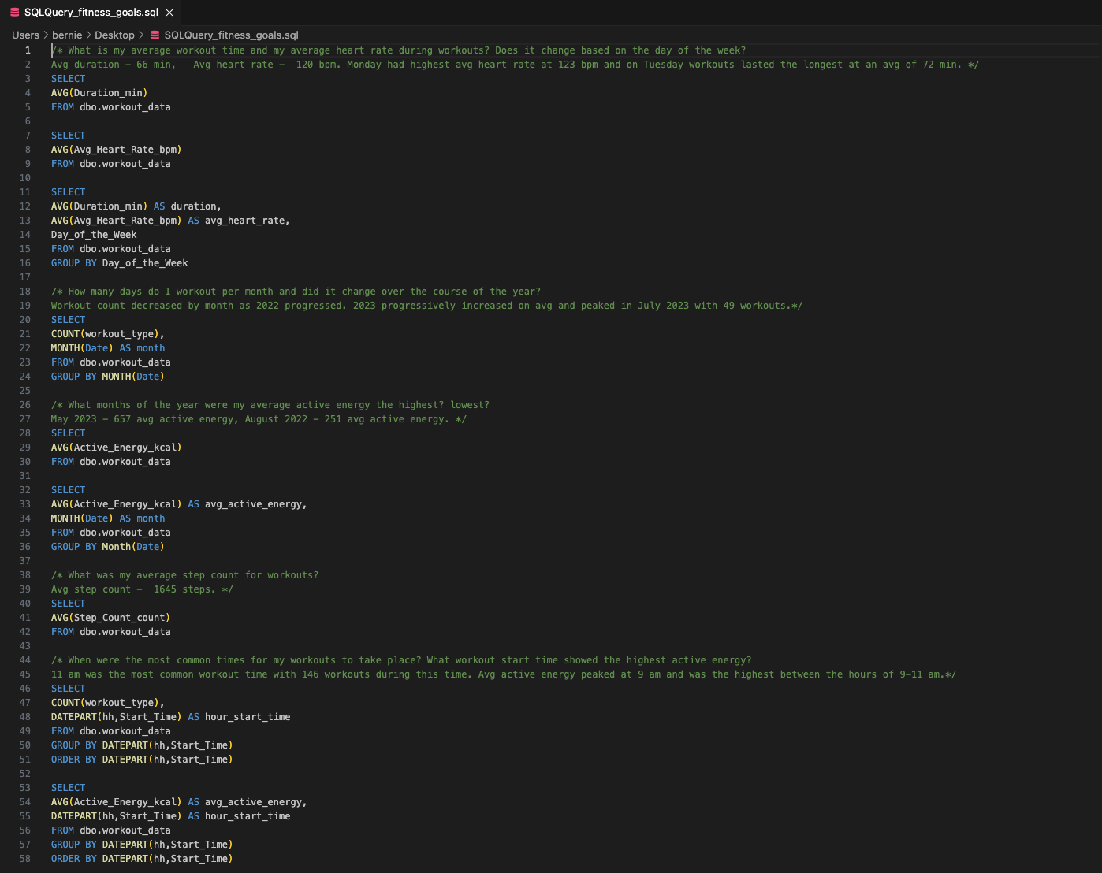

**Tableau Public & Figma**

**Tableau Public**

After my SQL query, I uploaded the excel file to Tableau Public to begin data visualization. I planned to create a dashboard visualizing key performance indicators(KPIs) at the top of the dashboard. These metrics are as follow:

1. **Average Heart Rate (beats per minute)**
2. **Average Duration (in minutes)**
3. **Average Active Energy (kilocalories)**
4. **Average Step count**

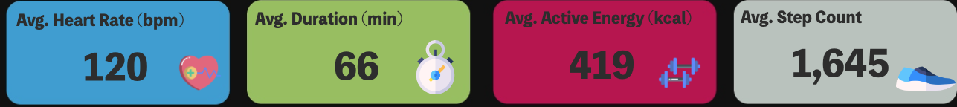

In addition to including the KPIs, I wanted to include the following graphs in my dashboard:

1. **Duration & Heart Rate by Day**  - shows the average duration of workouts in minutes and average heart rate (bpm) for workouts during different days of the week.

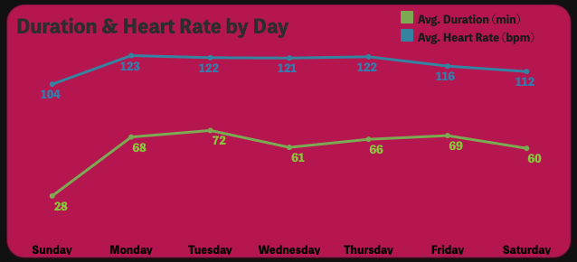

1. **Avg. Active Energy by Month** - displays the average active energy in kilocalories (kcal burned during workout) for every month between August 2022 to July 2023.

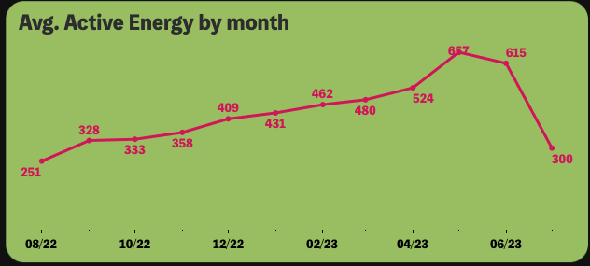

1. **Workout Count by Month** - displays how many workouts took place each month between August 2022 to July 2023.

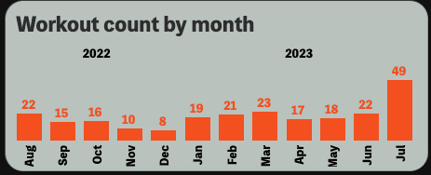

1. **Avg. Active Energy by workout start time** - shows the average active energy in kcal based on the workout start time. The x-axis shows time in military time format.

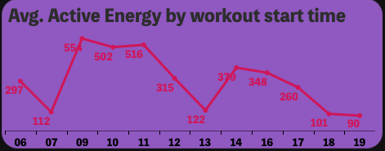

1. **Count of Workout start time** - displays the amount of workouts taken place based on their start time. The time is in military time format.

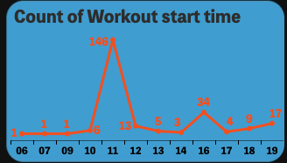

There is a filter at the top right of the dashboard and it filters by workout types. The filter allows multiple values (workout types) to be selected. The filter applies to every KPI and graph on the dashboard. This allows the differences in KPIs to be viewed by grouping workout types or by selecting workout types individually. It was useful in analyzing if I achieved my goals and answered many of my questions pertaining to my workouts and my cardiorespiratory fitness.

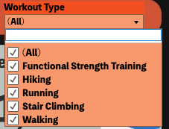

**Figma**

After creating all the graphs and KPIs that were to be included in my dashboard, I created the background template using Figma. Figma allowed me to graphically design a dashboard with a similar color scheme as the Apple fitness app. I also tried to complement the KPI metrics by using similar colored data points in the graphs. For example, the Avg. Heart Rate KPI was placed in the blue box and all the graphs that included Heart rate used a similar shade of blue to represent heart rate. This similar color representation was also used for the duration KPI and active energy KPI. I added icons to my Tableau dashboard from Flaticon.

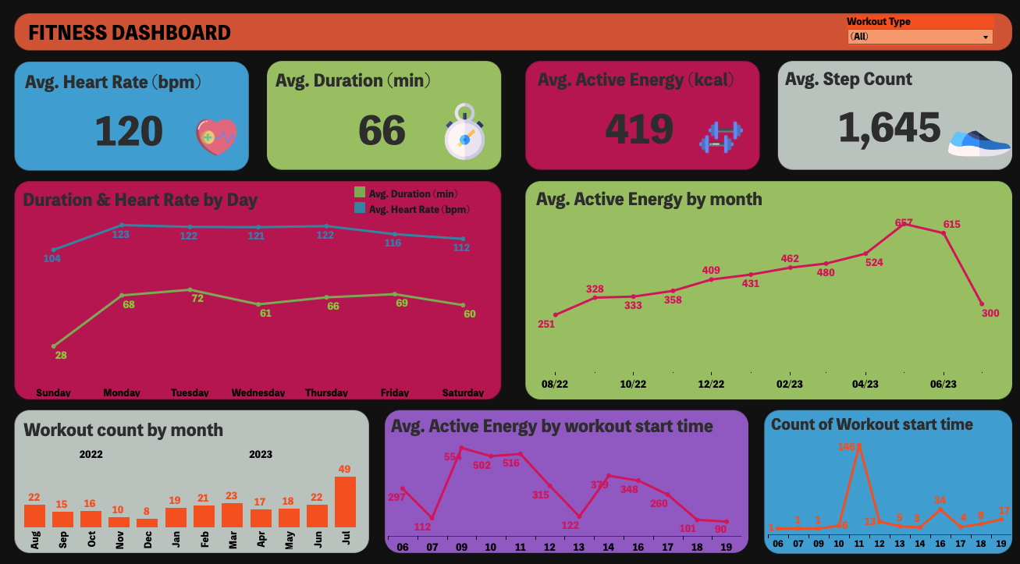

**Results**

**Summary of Data**

Below I've included a summary of the data with all values(workout types) included in the filter. This data is readily accessible as you open the Tableau dashboard for the first time:

1. Average Heart Rate (bpm): **120**
2. Average Duration (min): **66**
3. Average Active Energy (kcal): **419**
4. Average Step Count: **1,645**
5. Duration & Heart Rate by Day
   1. Sunday: Avg. HR(bpm): **104**, Avg. Duration(min): **28**
   2. Monday: Avg. HR(bpm): **123**, Avg. Duration(min): **68**
   3. Tuesday: Avg. HR(bpm): **122**, Avg. Duration(min): **72**
   4. Wednesday: Avg. HR(bpm): **121**, Avg. Duration(min): **61**
   5. Thursday: Avg. HR(bpm): **122**, Avg. Duration(min): **66**
   6. Friday: Avg. HR(bpm): **116**, Avg. Duration(min): **69**
   7. Saturday: Avg. HR(bpm): **112**, Avg. Duration(min): **60**
6. Average Active Energy by Month:
   1. August 2022: **251 kcal**
   2. September 2022: **328 kcal**
   3. October 2022: **333 kcal**
   4. November 2022: **358 kcal**
   5. December 2022: **409 kcal**
   6. January 2023: **431 kcal**
   7. February 2023: **462 kcal**
   8. March 2023: **480 kcal**
   9. April 2023: **524 kcal**
   10. May 2023: **657 kcal**
   11. June 2023: **615 kcal**
   12. July 2023: **300 kcal**
7. Workout Count by Month
   1. August 2022: **22**
   2. September 2022: **15**
   3. October 2022: **16**
   4. November 2022: **10**
   5. December 2022: **8**
   6. January 2023: **19**
   7. February 2023: **21**
   8. March 2023: **23**
   9. April 2023: **17**
   10. May 2023: **18**
   11. June 2023: **22**
   12. July 2023: **49**
8. Avg. Active Energy by workout start time
   1. 06:00: **297 kcal**
   2. 07:00: **112 kcal**
   3. 09:00: **554 kcal**
   4. 10:00: **502 kcal**
   5. 11:00: **516 kcal**
   6. 12:00: **315 kcal**
   7. 13:00: **122 kcal**
   8. 14:00: **379 kcal**
   9. 16:00: **348 kcal**
   10. 17:00: **260 kcal**
   11. 18:00: **101 kcal**
   12. 19:00: **90 kcal**
9. Count of Workout start time
   1. 06:00: **1**
   2. 07:00: **1**
   3. 09:00: **1**
   4. 10:00: **6**
   5. 11:00: **146**
   6. 12:00: **13**
   7. 13:00: **5**
   8. 14:00: **3**
   9. 16:00: **34**
   10. 17:00: **4**
   11. 18:00: **9**
   12. 19:00: **17**

**Insights**

The following insights are taken from the dashboard:

* Sunday workouts seem to be outliers with workouts being on average under 20 minutes and have a low average heart rate(HR) of 104 bpm. Workouts from Monday thru Thursday average between 61-72 minutes but the average HR range for these workouts are between 121-123 beats per minute. Friday and Saturday average HR fell out of the HR range from Monday-Thursday to 116 and 112, respectively.
* Average active energy by month increases steadily from the lowest average active energy in August 2022 to the highest average active energy in the month of May 2023. There is a large increase from 524 kilocalories in April 2023 to 657 kilocalories in May 2023. There is a sharp decline in average active energy from June 2023 to July 2023 due to 21 walking workouts in the month of July. This led to an increase in workout count and lowered the average active energy because walking workouts have an average active energy of 105 kilocalories.
* Amount of workouts steadily decreased from August 2022 to December 2022. Then, we see an increase in workouts per month until a peak of 49 workouts in July 2023.
* Peak workout start time based on average active energy is between 9am to 11am. Between these hours average kilocalories burned are between 502-554. Easily surpassing the average goal of 460 kilocalories burned per workout.
* Workouts after 6pm had the lowest average active energy due to them being about 80% walking workouts. Walking workouts are the least intensive workout type based on all the KPIs.
* 75% of workouts start at 11am or 4pm. Only 2 of those workouts are not Functional Strength Training. About 80% of walking workouts start from 6-7pm.

**Conclusion**

**What I Learned**

1. How to convert hh:mm:ss time format in Microsoft Excel to minutes time format.
2. How to use MONTH in SQL to only acquire the month and not the full date. Also, how to use DATEPART to only extract the hour from time values in SQL.
3. Tying the filter in my Tableau dashboard to be applied to all graphs and values using the same data source.
4. How to layer shapes in Figma to provide more creative design options to my future dashboards.

**Final Conclusion**

The insights from the previous section helped me answer all my questions and showed which goals I was able to achieve and what I need to focus on in future workouts. I was not able to have an average active energy of 460 kilocalories(kcal) for each workout that I did. However, functional strength training workouts are the majority of my workouts (75% of workouts recorded) and they averaged an active energy of 486 kcal compared to 419 kcal for all workouts recorded. My average workout duration is 66 minutes and the duration range for weekdays was 61-72 minutes. I was able to easily achieve my goal of workout durations of 45 minutes during weekdays. The goal I did not get close to achieving and needs a lot of work in the future is keeping my average heart rate between 135-154 beats per minute for every workout. I was only able to achieve an average heart rate of 148 bpm when the filter included only hiking, running, and stair climbing exercises. Functional strength training and walking exercises filtered together have an average of 119 bpm which is well below the goal of 135-154 bpm.

Moving forward, I need to research ways to improve the intensity of my functional strength training workouts that allow me to achieve a higher average heart rate. Another way to move closer to achieving this goal is to increase the amount of cardio workouts at the beginning or the end of my functional strength training workouts.

Thank you so much for reading my comprehensive analysis of my Fitness Data and I hope you enjoyed it and learned something along the way.

Please feel free to check out my portfolio and more [Tableau dashboards](https://public.tableau.com/app/profile/bernie.gonzalez)!